Chapter 8, Problem 41.

For the network in Fig. 8.89, find i(t) for t > 0.

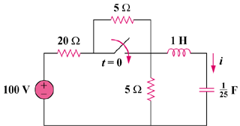

Figure 8.89
For Prob. 8.41.

